**Protocol for Monitoring Aquatic Invertebrates of Small Streams in the Heartland Inventory & Monitoring Network**

**SOP 3: Sampling Invertebrates and Collecting Habitat Data**

**Version 2.0 (8/8/2018)**

**Revision History Log:**

|  |  |  |  |  |  |
| --- | --- | --- | --- | --- | --- |
| Previous Version # | Revision Date | Author | Changes Made | Reason for Change | New Version # |
| 1.0 | 8 August 2018 | D.E. Bowles | Substrate measurement changed to 3 pieces, field forms updated | DeBacker et al. (2012) | 2.0 |
|  |  |  |  |  |  |
|  |  |  |  |  |  |
|  |  |  |  |  |  |
|  |  |  |  |  |  |

This SOP describes field procedures for selecting riffles to sample within a stretch and the process for randomly selecting sample points within a riffle. The SOP further explains procedures for collecting and processing invertebrate samples in streams, and for collecting associated habitat data. Appropriate QA/QC requirements are highlighted within the procedure descriptions.

**I. Riffle Selection within a Sample Reach**

1. The sample unit is a reach of the contiguous stream as defined in the protocol narrative. Sampling and habitat analysis will be restricted to three riffles in this reach (two sites at HOME).
2. Locate the lower boundary of the sample reach using the UTM coordinates shown in Table 1. The following landmark descriptors and site maps (see Appendix B) also are useful for locating the sampling reaches.

*EFMO*

Dousman Creek. Approximately 200 m upstream from the confluence with the Yellow River.

*GWCA*

Carver Creek. The first sampled riffle is about 15 m downstream of the west or downstream-most visitor’s trail crossing Carver Creek.

Harkins Branch. The first sampled riffle is located immediately upstream of the downstream (west) park boundary fence.

Williams Branch. The first sampled riffle is about 130 m downstream of the west trail crossing Williams Branch.

*HOME*

Cub Creek. *Upstream site*: SW corner of park downstream of bridge. *Downstream site*: 50 m NE of Highway 4 bridge.

*HEHO*

Hoover Creek. Approximately 125 m upstream of Parkside Drive in West Branch, Iowa.

*HOSP*

Bull Bayou. Approximately 250 m upstream of western park boundary where the stream exits the park.

Gulpha Creek. Approximately 250 meters upstream of the southern park boundary where the stream exits the park.

*PERI*

Pratt Creek. Approximately 100 m upstream of southern park boundary where the stream exits the park.

Winton Spring Branch. Immediately inside the south boundary of the park, and upstream of its confluence with Pratt Creek.

Lee Creek. Immediately downstream of the small spring on stream right located downstream of the bridge on park road.

*PIPE*

Pipestone Creek. 25 m below Lake Hiawatha directly above Circle Trail crossing.

*TAPR*

Fox Creek. Approximately 600 m due west of Highway 177 immediately across from the historic house and barn.

Palmer Creek. Approximately 1,200 m upstream from confluence with Fox Creek.

*WICR*

Skegg’s Branch. Approximately 30 m upstream of the park tour road crossing the stream.

Wilson’s Creek. Located between of second crossing bridge on park loop and the confluence with Terrell Creek.

Terrell Creek. The first sampled riffle is located about 70 m upstream of Hwy ZZ bridge.

Table 1. The streams that will be sampled in each network park and the UTM coordinates of the lower sampling stretch boundaries.

|  |  |  |  |
| --- | --- | --- | --- |
| **Park** | **Streams sampled** | **UTM Coordinates**  **(Northing, Easting)** | **Index Period** |
| GWCA | Carver Creek  Harkins Branch  Williams Branch | 4094380.11, 379254.85  4094493.46, 378963.70  4094466.25, 379268.19 | May-June |
| EFMO | Dousman Creek | 4772108.08, 645475.84 | July-August |
| HEHO | Hoover Creek | 4614462.87, 637697.89 | July-August |
| HOME | Cub Creek | 4462337.67, 684059.84 | August-September |
| HOSP | Bull Bayou  Gulpha Creek | 3819096.45, 489743.19  3820036.11, 496779.10 | June-July |
| PERI | Pratt Creek  Winton Spring Branch  Lee Creek | 4033256.21, 407127.86  4033296.3, 407032.2  4033355.5, 406034 | May-June |
| PIPE | Pipestone Creek | 4877259.61, 714204.77 | July-August |
| TAPR | Fox Creek  Palmer Creek | 4256985.51, 713944.53  4263176.10, 710907.56 | April-May |
| WICR | Skegg’s Branch  Terrell Creek  Wilson’s Creek | 4105745.65, 463391.47  4104000.832, 462818.328  4104580.870, 464167.047 | May- June |

1. Riffle selection was determined *a priori*, with the three riffles to be sampled being located in consecutive order upstream of the first riffle as indicated in Fig. 1. Sampling is conducted in a downstream to upstream direction.

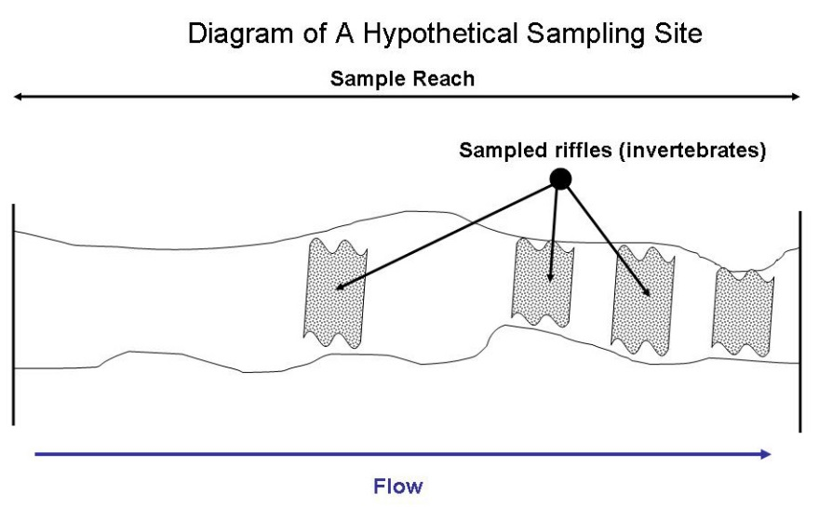

**Figure 1.** Diagram of riffle location within a sample reach.

* 1. For Cub Creek, located at HOME, the sampling areas are the upper and lower reaches of the stream as it flows through the park (Fig. 2).

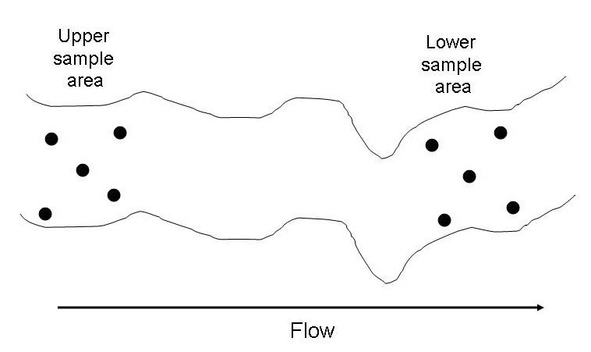

**Figure 2**. Diagram showing approximate placement of Hester-Dendy samplers in Cub Creek, HOME.

* 1. Specific methods for placing samplers are described below.

**II. Collecting Benthic Samples and Associated Habitat Data from Riffles**

**Procedure:**

1. These procedures apply to streams at GWCA, HEHO, PERI, PIPE, TAPR, and WICR. Instructions for HOME are shown below.

2. Prior to collecting benthic samples and taking habitat measurements, always complete data sheet information for park code and stream name (e.g., PIPE, Pipestone Creek), date and time of survey, sample season, and initials of personnel who collect the samples.

3. Deploy datasonde for taking continuous CORE 5 water quality readings using the procedures described in SOP#4.

4. Collect three benthic samples per riffle. Benthic invertebrate samples will always be taken in an upstream direction. Individual benthic samples from riffles will be collected using the following *a priori* randomization procedure:

a) The sampling area is divided into three equal portions based on the measured length of the riffle as shown in Fig. 3. First and foremost, the effective sampling area of the riffle will be based on safety of personnel, accessibility, and other pertinent factors determined by the investigators’ best judgment at the time of sampling. The upper and lower riffle boundaries generally will be based on a visual assessment of gradient, velocity, and substrate characteristics. Care should be used to avoid including the deeper, downstream portion of the riffle as it transitions to deeper run habitat with more of v-shaped channel.

b) Collect individual benthic samples starting at river left (1/4 point), then alternating to the middle, and finally the right (3/4 point). Samples will be collected at the approximate midpoint of each portion. Indicate sampling sequence on the data sheet (L, M, or R). Approximate position of the samples is shown in Fig. 3.

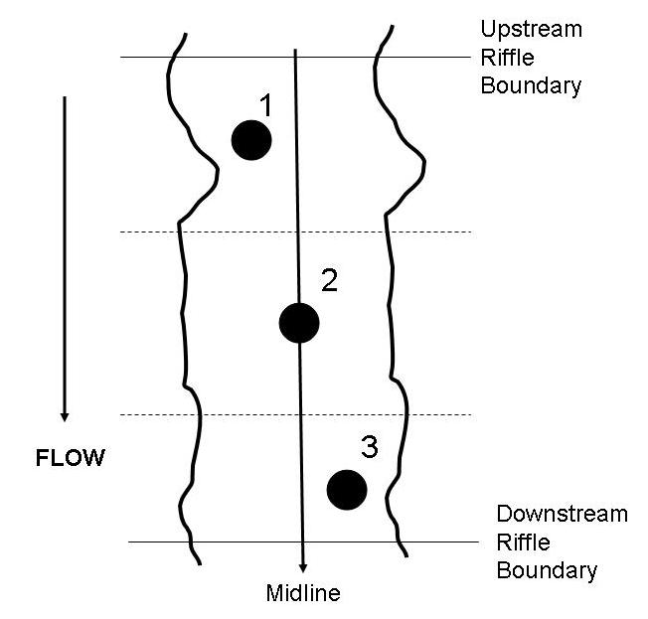

**Figure 3**. Diagram of sample locations within a riffle.

Note: Sample sequence should be altered only if the original starting point presents danger to the collector or if it is not accessible. Some riffles may be wider than long and, in these instances, samples can be taken from left to right in equally spaced increments.

c) Samples will be collected with a Surber stream bottom sampler (~500 µm mesh, 0.093 m2 sampling area) (Fig. 4). Place the sampling frame firmly against the stream substrate so that the opening is oriented directly into the stream current.

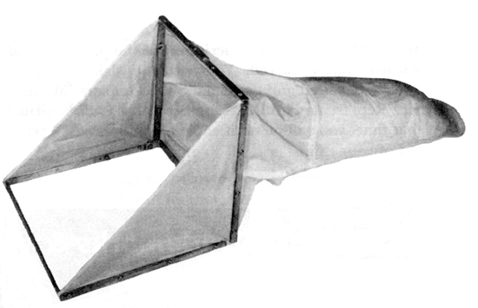

Figure 4. Surber stream bottom sampler.

5. For each benthic sample, record habitat measurements based on visual estimates from within the sample frame on the habitat data form. Percentage categories are: 0= none (0%), 1= sparse (<10%), 2= moderate (10-40%), 3= heavy (40-75%), 4= very heavy (>75).

* 1. percent embeddedness of the substrate (e.g., bedrock & hardpan clay = 0% embeddedness; sand, clay, silt = 100% embededdness)
  2. percent periphyton
  3. percent filamentous algae
  4. percent vegetation

1. Record dominant substrate size within the sampling area.

Note: This technique is used to assess the dominant substrate in the sample area. It is not intended to fully characterize the substrate profile of the stream bottom. Substrate data is not collected from Cub Creek at HOME since the substrate uniformly consists of sand.

1. After the net and sample frame have been placed on the stream bottom, visually estimate the dominant substrate size as an average of three randomly (i.e., blind touch) selected substrate pieces taken from within the sampling frame.
2. The Wentworth Scale (Table 2) is used for assessing substrate size.
3. A Wentworth Scale category field sheet (provided at the end of this SOP) is intended to be used for rapid measurement of substrate in the field. A piece of substrate belongs to the smallest size box that it will fit through on any axis.
4. Record the average dominant substrate size code on the field sheet.

**Table 2**. Substrate size classes to be used for characterizing substrate based on the Wentworth Scale.

|  |  |  |
| --- | --- | --- |
| **Size Code** | **Particle Diameter Range (mm)** | **Category** |
| 1 | <0.062 | Silt/clay |
| 2 | 0.062-0.125 | Very fine sand |
| 3 | 0.125-0.25 | Fine sand |
| 4 | 0.25-0.50 | Medium sand |
| 5 | 0.50-1 | Course sand |
| 6 | 1-2 | Coarse sand |
| 7 | 2-4 | Fine gravel |
| 8 | 4-5.7 | Medium gravel |
| 9 | 5.7-8 | Medium gravel |
| 10 | 8-11.3 | Coarse gravel |
| 11 | 11.3-16 | Coarse gravel |
| 12 | 16-22.6 | Small pebble |
| 13 | 22.6-32 | Small pebble |
| 14 | 32-45 | Large pebble |
| 15 | 45-64 | Large pebble |
| 16 | 64-90 | Small cobble |
| 17 | 90-128 | Small cobble |
| 18 | 128-180 | Large cobble |
| 19 | 180-256 | Large cobble |
| 20 | 256-362 | Boulder |
| 21 | 362-512 | Boulder |
| 22 | 512-1024 | Boulder |
| 23 | >1024 | Boulder |
| 24 | Bedrock | Bedrock |

1. Record current velocity and depth.

Average velocity and depth are measured concurrently at each sample point, immediately in front of the sample frame (Fig. 5). Depth and velocity can be measured by a third team member while the other two members collect the benthic sample described in step 8 below. Measurements are taken using a current meter attached to a top-setting wading rod. The rod allows for quick and easy measurements of depth with incremental (cm) markings and an adjustable arm that places the current meter at the proper depth for measuring velocity (60% of the depth from the surface of the water). Velocity should be recorded in meters per second. Greater detail regarding use of current meters and the wading rod is provided in SOP#5 “Measuring Stream Discharge.”

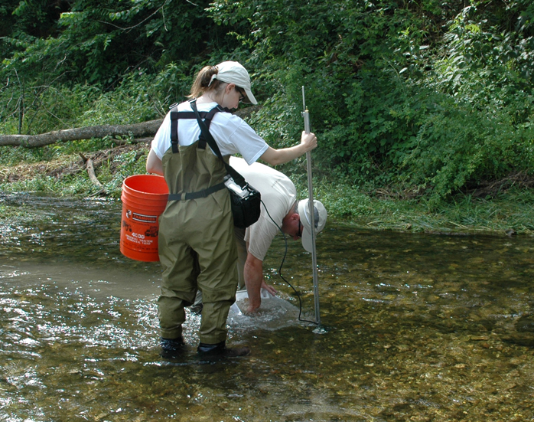

**Figure 5**. Measuring depth and current velocity in front of the collecting net.

8. Benthic sample collection (Surber Sampler)

a. While one team member holds the net firmly against the stream bottom facing the current, a second team member examines all large substrate pieces and scrubs them with a soft brush in order to dislodge any attached invertebrates so they are carried into the collecting net (Fig. 6). Forceps may be needed to remove snails and attached caddisflies. Discard the substrate outside the sampling area once scrubbing is completed. When this step is completed, a garden cultivation tool is used to agitate the entire area within the net sample frame for a timed period of 2 minutes. At the end of 2 minutes the net can be lifted from the stream bottom, but with sufficient caution so as not to spill the sample.

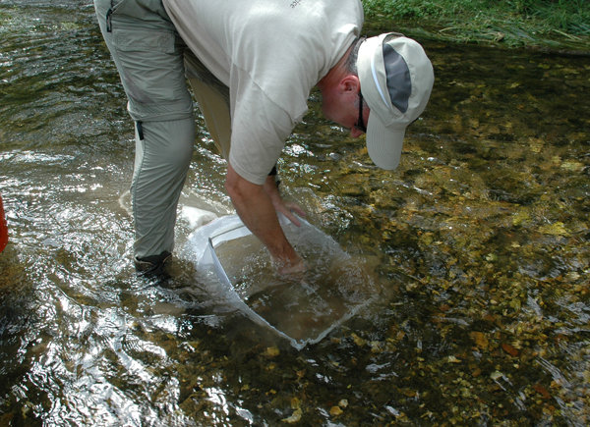

**Figure 6**. Collecting a Surber sample.

b. Large debris or rocks should be inspected for attached organisms and then removed from the sample. Pour and rinse the contents of the net into a wash bucket with a 500µm mesh sieve and rinse the sample by swirling the bucket in water using care not to submerge the bucket. Continue this process until all the fine silt and other sediments have been washed from the sample. Remove the sample contents from the wash bucket and place them in the sample container (Fig. 7). Inspect the net, bucket, and sieve for any remaining organisms and carefully place them in the sample container. Excess water in the sample container can be drained into the sieve and inspected for organisms so that the preservative is not overly diluted.

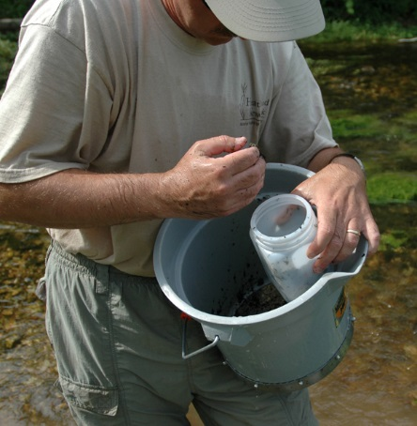

**Figure 7.** Transferring the sample from the wash bucket to the sample container.

c. Once all organisms have been removed from the net, fill the jar with preservative (95% ethyl alcohol), ensure that the container is properly labeled (example sample labels are provided at the end of this SOP), and tightly close the lid. Sample debris must be completely covered by preservative. Labels must be written in waterproof ink on 100% ragbond paper.

1. Repeat this procedure for each discrete sample. Prior to leaving the site, recheck the samples to ensure they have been properly labeled and tightly closed, and ensure data sheets are properly completed.
2. Record any necessary notes about the collection site, difficulties with specific samples, and bivalve mollucs collected but returned to the benthos, or other pertinent notes.
   1. Hester-Dendy sample collection
3. Hester-Dendy samplers (Fig. 8) are used only at Cub Creek, HOME. For maximum data integrity across years, each Hester-Dendy sampler should use a standard plate configuration as follows: 0.3 cm tempered hardboard cut into 7.6-cm square plates (3-inch) and 2.5 cm (1-inch) square spacers placed on a 1/4" (0.64 cm) eyebolt. Nine plates are used making a surface area of 0.10m2 for each sampler.

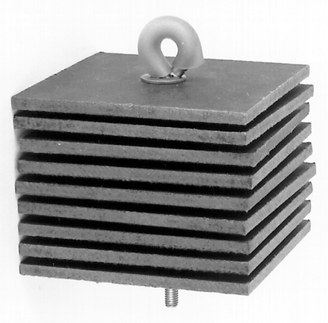

**Figure 8**. Hester-Dendy multiplate sampler.

1. Hester-Dendy samplers require a deployment and retrieval trip to complete one invertebrate sample. The samplers should be spaced at least one meter apart in the deployment area. The samplers are deployed using the nylon rope, tied to the eye-bolt, and suspended from sturdy woody vegetation (e.g., stable root wads) or other support, such that they are submerged at least 6 cm above the streambed, and 6 cm below the surface. Flotermersh (2006) recommends exposure periods of four to six weeks to allow for colonization of biofilm and subsequent invertebrate fauna—a 30 day exposure period is used in this protocol. Samplers are usually deployed at 1- to 3-m depths. Deployment depth is chosen so that receding or rising waters during the exposure period will not leave samplers dry, buried in mud, or too deep to retrieve. Typically, 5 Hester-Dendys are placed per sampling reach (Flotermersh 2006). Placing multiple samples per reach and compositing data also helps buffer the effects of sampler loss from flooding.
2. Because Hester-Dendy samplers are an entirely artificial sampling medium, habitat data as described above excluding CORE 5 data, are not collected. HOME staff collect CORE 5 data using their own forms, which are not included here.
3. When the samplers are retrieved, and where practical, bring the sieve bucket up and around the sampler while it is place. If that is not possible, individual samplers should be slowly lifted to the water’s surface and immediately placed in a wash bucket (500 m screen mesh) to capture any escaping invertebrates. Transfer the samplers and collected debris to a small bucket or plastic tub to facilitate scrubbing the sampler plates (Fig. 9). Inspect the bottom of the wash bucket to ensure no invertebrates remain. Remove the wing-nut that holds the plates onto the support bolt and separate the individual plates. While the sampler plates are in the plastic tub, carefully scrape or brush each plate to remove attached invertebrates. The contents that have been deposited in the tub are then sieved to remove silt and fine debris and preserved in 95% ethyl alcohol for laboratory processing.

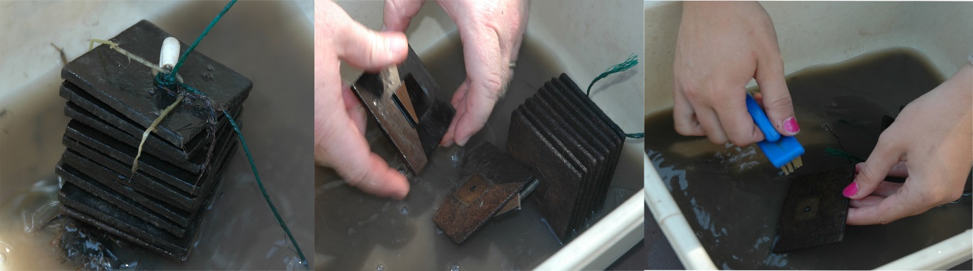

**Figure 9**. Procedure for removing attached invertebrates from individual Hester-Dendy plates.

10. Record any necessary notes about the collection site or specific samples.

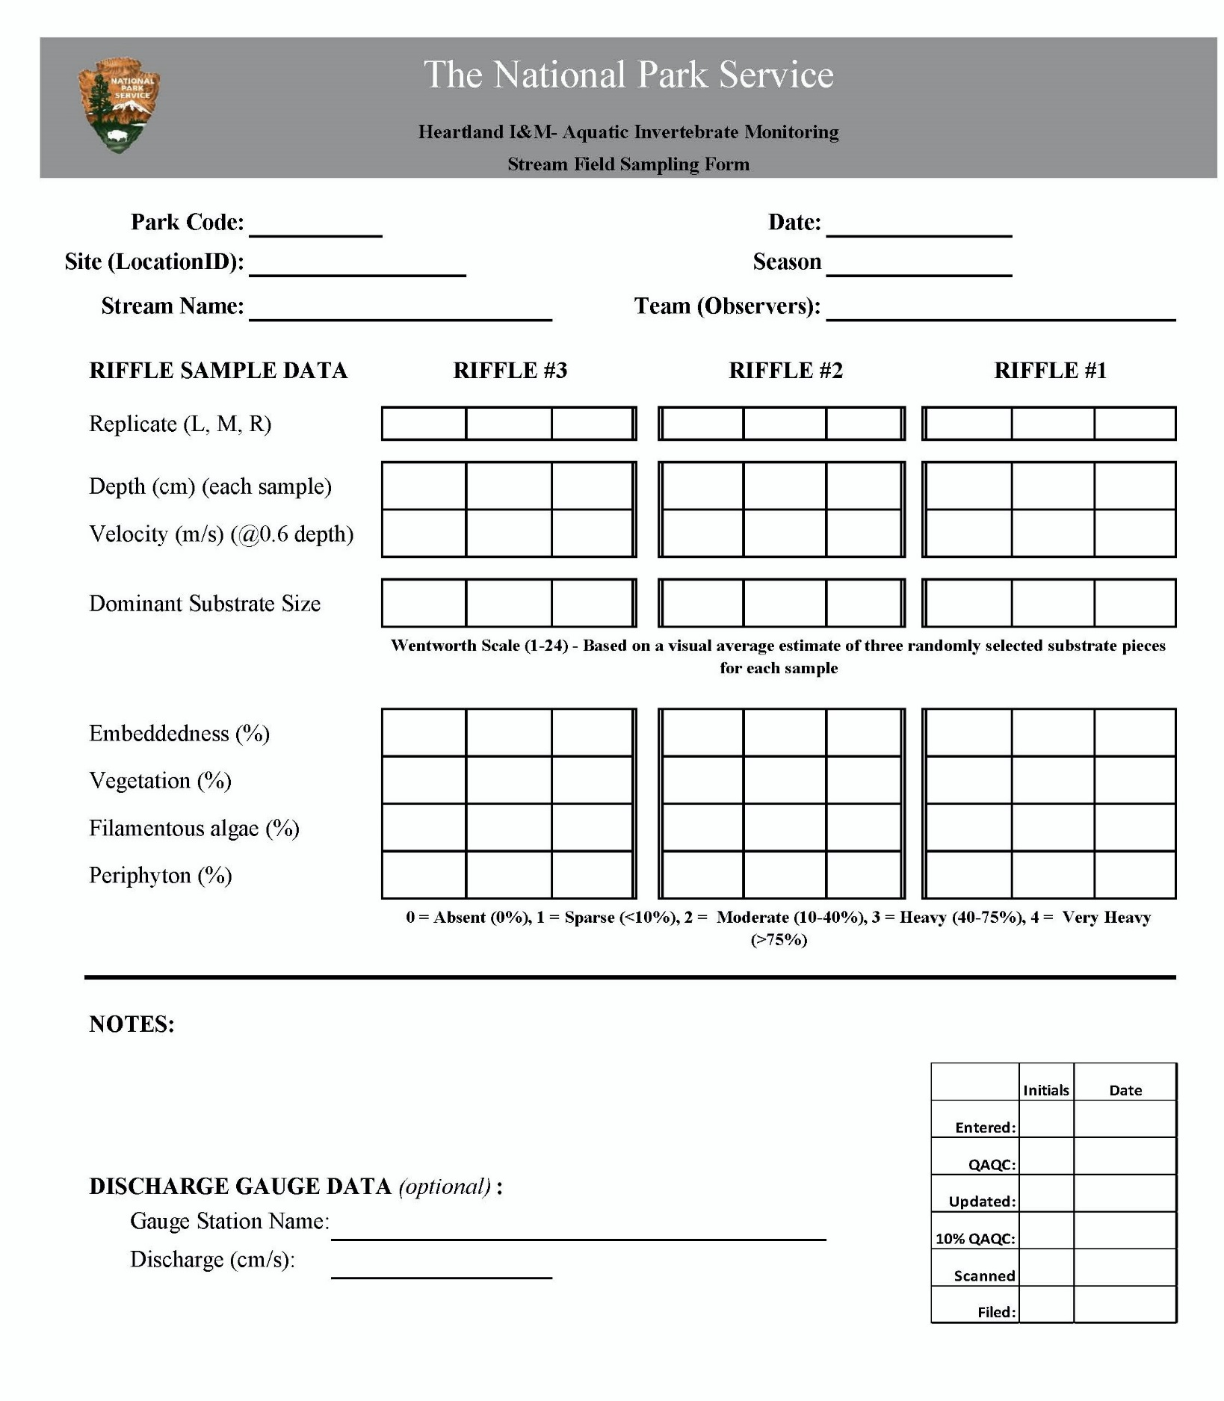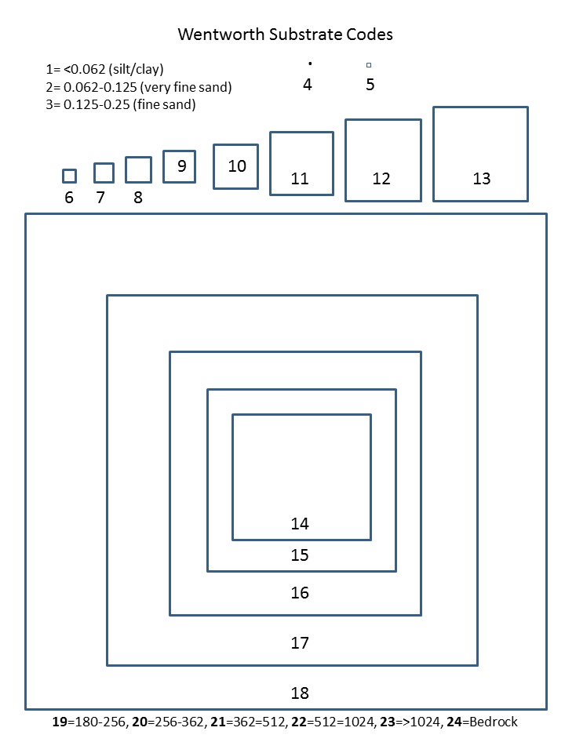

**Labels for Surber samples**



**Labels for Hester-Dendy samples**

